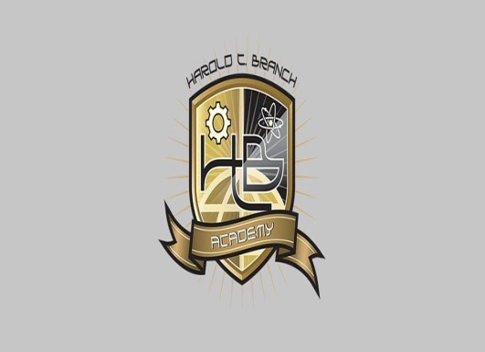

Harold T Branch Academy

For Career and Technical Education

Mrs. Simmons

[IMSimmons@ccisd.us](mailto:IMSimmons@ccisd.us)

Conference: M/W 1:00pm – 2:20pm

T/T 8:00am – 9:20am

Room: 117 361/878-4780 x 22607

**Classroom Procedures:**

1.Students should be sitted and prepared to work when class begins.

2. Stay on task.

3. Doors remain closed and locked at all times.

4. The bell does not dismiss you.

5. Restrooms should be used during your passing periods.

6. Cell phones are allowed in class but should be kept in your purse, backpack, pocket or you may plug into power strip located at the back of the classroom. Cell phones cannot be used in class unless you are working on a project. This will be at teacher’s discretion. Phone will be picked up and taken to office if this rule is broken.

7. Collaboration is highly encouraged in the classroom with classmates. Keep your voices down. Respect each other.

8. Food and drinks are not allowed in the computer lab.

Failure to comply with any of these classroom rules will have consequences.

1. Conference with student.
2. Phone call to parent
3. Conference with principal.

**Problems & Solutions** is a course that allows the students to prepare for the rigor of college level coursework. Students will also complete extensive research on their chosen career, the education required for that career and the cost associated with that post-secondary education.

Students will develop a career portfolio, learn soft skills for personal and business use; Skills in customer service, leadership, finances in work, safety in the workplace and different types of communication skills will also be explored and practiced.

Students will practice and learn how to create business oriented forms, letters, documents using Microsoft Office applications. Google docs, sheets, slide and forms will also be introduced and practiced.

|  |  |
| --- | --- |
| Major Grades | 60% |
| Tests |  |
| Projects |  |
| Organization of Folders |  |
|  |  |
| Minor Grades | 40% |
| Daily Assignments |  |
| Class Participations |  |

Cheating- Cheating is not only receiving answers, but knowingly giving the answers as well. All cheaters will receive a ZERO on the assignment.

Cheating on the MOS certification test will receive a ZERO and lose their privilages to take any other certification test.